Checklist for Minutes
Is the committee name correct?
Is the chair and the vice-chair name correct?
Is the date correct? With the correct superscript?
Is your attendance in alphabetical order?
Do you have titles under the appropriate people (ex: Secretary under the name of the secretary)? See example in picture 1
Is your attendance table free of gaps between the names?
Does everyone have a vote or a tick in the vote column?
Are your totals correct at the bottom? (Note: Absent should include excused and unexcused.) See example in picture 2
Do you also have an attendance count for the exec side?
Have you included everyone in “also in attendance” and are the names not bolded?
Does your business have the correct three tabs – report, discussion, voting
Do you have a name next to every point that was made and is it spelled correct?
Is everything bolded correctly? Only bolding the section titles etc.
Is the font Times New Roman and 12 points?
Is your document titled MM.DD.YY ‘committee name’ minutes?
Are your minutes free of spelling errors?

Picture 1
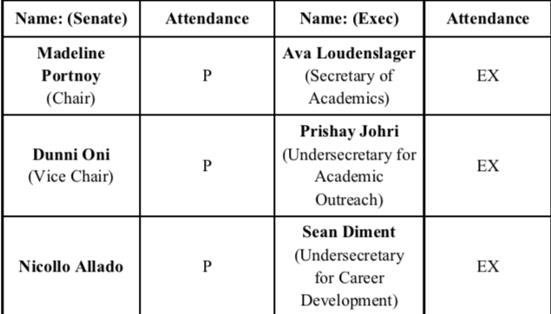

Picture 2 – notice you include Senate AND exec totals
